PAPER SUMMARY REPORT

Swallowing Accelerometry Signal Feature Variations with Sensor Displacement
Authors | Khondaker A. Mamun, Catriona M. Steele, Tom Chau
Venue | Medical Engineering & Physics, Vol. 37 (2015), pp. 665–673 (Elsevier / IPEM)
DOI | 10.1016/j.medengphy.2015.04.007
Affiliations | Ahsanullah University of Science & Technology (Bangladesh); Holland Bloorview Kids Rehabilitation Hospital; University of Toronto; Toronto Rehabilitation Institute
Research type | Experimental biomedical signal-processing study (healthy adults)
Keywords | Dysphagia, accelerometry, swallowing, sensor placement, feature robustness

1. Introduction and Motivation
Swallowing (deglutition) is a complex neuromuscular process. People with stroke, cerebral palsy or Parkinson’s disease often develop dysphagia (swallowing difficulty), which can lead to aspiration – food or liquid entering the airway below the vocal folds – and then to pneumonia, malnutrition, dehydration or death.
The clinical gold standard, the video-fluoroscopic swallowing study (VFSS), needs expensive X-ray equipment and specialist staff, and exposes patients to ionising radiation, so it is unsuitable for routine, day-to-day monitoring. Dual-axis swallowing accelerometry – a small accelerometer taped to the neck below the thyroid cartilage – is a promising non-invasive alternative, and earlier studies had already used it with pattern classifiers to detect aspiration.
Research gap: all previous work recorded signals only at one fixed “baseline” position. In real clinical use the sensor will inevitably be placed slightly differently each time. It was unknown whether such small displacements change the signal features, and therefore the accuracy of aspiration classifiers.

2. Objective
To quantify how dual-axis swallowing accelerometry signal features change when the sensor is moved away from the baseline position, and to identify an admissible placement region and the feature domain most robust to placement error.

3. Methodology
- Participants: 14 healthy adults (12 female, 2 male; aged 18–65, mean 26 ± 8 years) with no swallowing, neurological, head/neck or airway history. Ethics approval from Holland Bloorview (REB #12-315).
- Sensor positions: 13 in total – baseline (neck midline, just below the thyroid cartilage during quiet breathing) plus 2, 4, 6 and 8 mm superior, inferior and to the right of baseline. Each participant did 9 of the 13 positions; all 13 were covered across participants.
- Task: 10 × 10 ml water swallows per position, head upright, triggered by an audible cue.
- Instrumentation: ADXL322 dual-axis accelerometer aligned to anterior–posterior (AP) and superior–inferior (SI) axes; 10× pre-amplifier with 0.1 Hz–3 kHz band-pass filter; sampled at 10 kHz via LabVIEW.
- Segmentation & pre-processing: 1,340 swallow segments extracted with sequential fuzzy c-means plus manual check; then (1) FIR whitening, (2) spline-based head-motion artifact removal, (3) 10-level discrete Meyer wavelet de-noising with soft thresholding.
- Feature extraction (35 features): Time domain – mean, median, variance, skewness, kurtosis, entropy, regularity, memory, Lempel–Ziv complexity, plus AP–SI mutual information, co-predictability and cross-correlation. Frequency domain – peak frequency, centroid frequency, bandwidth. Time-frequency – wavelet energies (levels retaining 95% of energy) and wavelet entropy.
- Statistics: Lilliefors test showed non-normal data, so the non-parametric Friedman test (α = 0.05) compared baseline against offset positions in each direction, with Wilcoxon signed-rank post-hoc tests (no multiple-comparison correction, deliberately to be more sensitive).
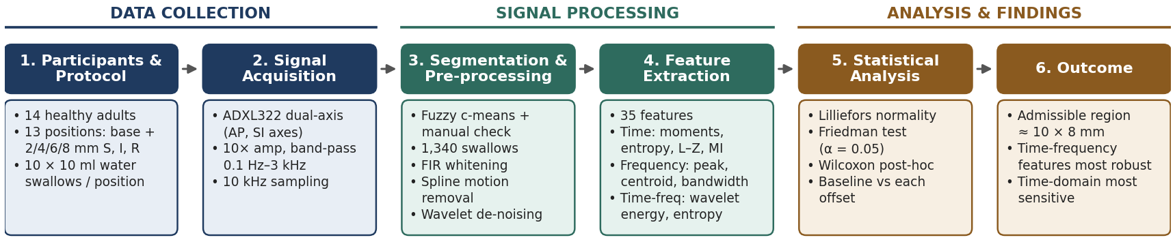
Figure 1. Methodology block diagram – from data collection to statistical analysis of sensor-displacement effects.

4. Key Results
Offset direction | Features changed significantly (of 35) | Notes
Superior | 6 | e.g. AP kurtosis, AP entropy, AP/SI regularity, SI centroid frequency
Inferior | 10 | e.g. AP/SI variance, SI entropy, AP–SI co-predictability, wavelet energies
Right (lateral) | 11 | e.g. SI memory, cross-correlation, bandwidth, SI wavelet entropy

- The majority of features were not affected by small displacements in any direction.
- Time-domain features were the most sensitive (especially entropy-related features); time-frequency (wavelet) features were the most robust.
- The sensor can move up to 6 mm above, 4 mm below and 4 mm lateral to baseline without significantly changing time-frequency features – an admissible region of about 10 mm (superior–inferior) × 8 mm (medial–lateral), assuming symmetry.

5. Discussion
The authors explain the changes through laryngeal anatomy. Moving up puts the sensor over the stiffer thyroid cartilage (larger AP variance, less entropy, higher SI centroid frequency). Moving down places it over the cricoid/tracheal cartilage, further from the hyoid, so SI variance falls and AP and SI signals become decoupled. Moving sideways puts the sensor more over cartilage than ligament; this shifts energy from low to high frequencies and raises wavelet entropy at 8 mm. These findings support an earlier aspiration classifier that used only time-frequency features.

6. Limitations
- Only healthy young adults were tested – results may differ in patients or in people with loose skin or more adipose tissue.
- Only thin (water) boluses were used; thicker consistencies were not tested.
- Small sample (14 people, mostly female), only right-side lateral offsets tested, and no correction for multiple comparisons.

7. Conclusion and Takeaway
Swallowing accelerometry features for thin liquids are largely invariant to small placement errors around the baseline position, and time-frequency features are the most robust. In practice, this means classifiers built on wavelet features should tolerate the placement variation expected in routine clinical use. That makes accelerometry more practical as a low-cost, radiation-free dysphagia screening tool.

